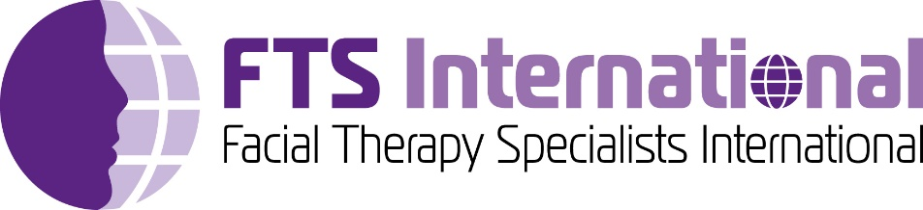

APPLICATION FORM

Mentoring for Specialist Facial Palsy Therapists

*\*\* Please note: It is a pre-requisite that you have completed the foundation FTSI course online or in person (or equivalent) to be able to apply for mentoring \*\**

To arrange your mentoring session(s), please complete and return this application via email to [info@facialtherapyspecialists.com](mailto:info@facialtherapyspecialists.com)

***The sessions will be booked on receipt of your payment via BACS.***

|  |  |
| --- | --- |
| Name | Click or tap here to enter text. |
| Email | Click or tap here to enter text. |
| Tel no. | Click or tap here to enter text. |
| Profession | Physiotherapist  Speech Therapist  Occupational Therapist  Other  please specify: |
| Place of Work | Click or tap here to enter text. |
| Type of work | NHS  Private |
| Current FTS Member | Yes  No |
| Facial Palsy Courses completed | **FTS Foundation course**  FTS Advanced course  Other  please specify: |
| Average number of facial palsy patients seen per week | Click or tap here to enter text. |
| Number of mentoring hours requested | Click or tap here to enter text. |
| What specific areas would you like to cover in your mentoring session(s)?  *If you would like to discuss specific patient cases, it is advisable to provide an information summary ahead of the session having got consent from the patient to share their information.* | Click or tap here to enter text. |
| If you would prefer a specific mentor (see list overleaf) please specify here *(please note this cannot be guaranteed)* | Click or tap here to enter text. |

**The cost is £100 per hour, payable by BACS.**

**If requesting funding from your employer, please secure your place by paying FTS-International directly and then requesting reimbursement from your employer.**

**To pay by BACS**: Account name: Facial Therapy Specialists, Sort Code: 40–15-07, Account Number: 41808567, Reference: your name.

*Please inform* [*info@facialtherapyspecialists.com*](mailto:info@facialtherapyspecialists.com) *as soon as you have paid to confirm remittance and book session date(s)*. *Thank you.*

**UK Mentors:**

Suzi Allen

Advanced Physiotherapist specialising in Facial Palsy,

Queen Elizabeth Hospital NHS Foundation Trust, Facial Palsy MDT.

Botulinum Toxin practitioner.

Course leader for Facial Therapy Specialists International.

Catriona Neville

Extended Scope Practitioner Physiotherapist specialising in Facial Palsy,

Queen Victoria Hospital NHS Foundation Trust, Facial Palsy MDT.

Botulinum Toxin practitioner and trainer. Independent prescriber.

Course leader for Facial Therapy Specialists International.

Tamsin Gwynn

Advanced Physiotherapist specialising in Facial Palsy,

Queen Victoria Hospital NHS Foundation Trust, Facial Palsy MDT.

Botulinum Toxin practitioner and trainer. Independent prescriber.

Course leader for Facial Therapy Specialists International.

Sarah Kilcoyne

Principal Specialist Speech and Language Therapist,

Oxford University NHS Foundation Trust, Facial Palsy MDT.

Specialist in paediatric facial palsy management.

Course leader for Facial Therapy Specialists International.

Helen Martin

Advanced Physiotherapist specialising in Facial Palsy,

St Helens and Knowsley Teaching Hospitals NHS Trust, Facial Palsy MDT.

Botulinum Toxin practitioner. Independent prescriber.

Course leader for Facial Therapy Specialists International.

Karen Young

Advanced Physiotherapist specialising in Facial Palsy,

Queen Victoria Hospital NHS Foundation Trust, Facial Palsy MDT.

Botulinum Toxin practitioner. Independent prescriber.

Course leader for Facial Therapy Specialists International.

**North America Mentors:**

Jodi Janczewski

Expert Clinician Physical Therapist specializing in Facial Palsy,

University of Wisconsin Hospitals and Clinics,

UW Health Facial Nerve Clinic multidisciplinary team member,

Neurologic Certified Specialist.

Course assistant for Facial Neuromuscular Retraining Workshop, US based course

Jackie Diels

Expert Clinician Occupational Therapist specializing in Facial Palsy.

Owner solo private practice: Facial Retraining, LLC (2017-present).

Formerly University of Wisconsin Hospitals and Clinics (1986-2018);

UW Health Facial Nerve Clinic multidisciplinary team member (2014-2018).

Co-Instructor, Facial Neuromuscular Retraining Workshop, US based course.